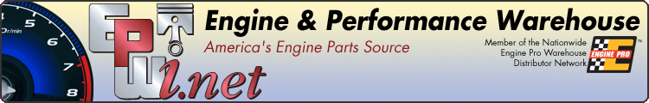





  
  
  

Beginning 10/15/2018 we are making some changes to your options to receive your invoices.
 | 
EPWI will no longer routinely mail (USPS) invoices to customers. Invoices will continue to be included with product shipments, except on most drop ship orders. Invoices and credit memos will also automatically be emailed to whomever you designate. These emails include tracking numbers. Previously, only orders generated on epwi.net were automatically emailed. All your invoices, statements and much more are available 24/7 on www.epwi.net. To confirm or add email addresses, please email admin@epwi.net


Check Out The Great Deals Below,
Going on NOW Until November 30, 2018
﻿or visit epwi.net for more information

  
  
  $100.00 OFF ANY
  World and Dart Blocks
  

$50.00 OFF ANY
Pair of Performance Heads
Excludes EngineQuest and Stock Replacement Iron Heads

  
  
  
  

  
  
  

  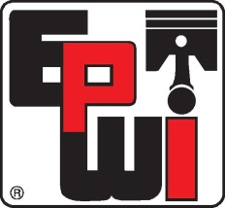
  
  
  $50.00 OFF ANY
  Performance Rotating
  Assembly
  Includes Balanced Rotating Assemblies

With Any Combination Of The Above Fall Specials,
Include a Pre-Paid Pallet When The Total Invoice Exceeds $3,500!

  5% OFF ANY RedHorse Order Over $500.00
  
  

  
  Engine Stands,
  ﻿Hoists and Jacks
  
  Engine Test Stand
  
  
  Some Pioneer Items Not Included.
  Categories 902/903
  ﻿Shop Supplies
  5% Discount on Shop Supplies and Tools
  
  
  
  Engine Builder Tools,
  Category 902
  



